This ELF receiver is designed for receiving extremely low frequency signals between d.c. and 55 Hz, rejecting all signals above 55 Hz including 60 Hz power line hum. The design can be easily adapted to reject 50 Hz instead 60 Hz. The ELF receiver employs low noise ICs, and can be used with a variety of detectors, including magnetic field coils and electric field antennas such as 'tree antennas' and differential ground rod sensors. The gain of the receiver can be easily modified to match the requirements for the various sensors. Differential inputs with a high common mode rejection ratio and large common mode range allow for detection of very weak differential signals while rejecting common mode noise. A full range, unfiltered output is also provided.

Design Overview

The first stage of this ELF receiver is a Low Noise Differential Front End Preamplifier (fig.1). This stage amplifies the differential input from the sensor and converts this signal from differential to a ground-referenced form for more amplification. The final op amp in this circuit forms two poles of a 12th order 60 Hz Butterworth lowpass filter and provides antialiasing for the switched capacitor filter stages to follow. A signal proceeding this filter stage can be output for full frequency detection of signals up to at least 100 KHz, depending on the sensor used. For 50 Hz rejection, the lowpass filter stage should be modified by changing R17 and R19 to 19.6K (1% metal film).

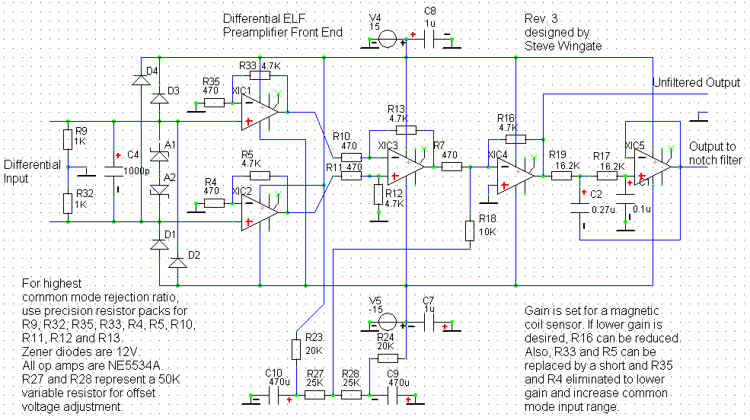
Fig.1

The second stage (fig.2) is an 8th Order Butterworth Switched Capacitor 60 Hz Notch Filter. The clock frequency is 12 KHz, but can be changed to 10 KHz to create a 50 Hz notch filter. The gain of this stage is 15 dB. This stage and the one that follows employs a Linear Technologies LTC1068-200 IC which uses an SSOP-28 case so you will need to order converter boards or sockets if you are using point-to-point wiring.

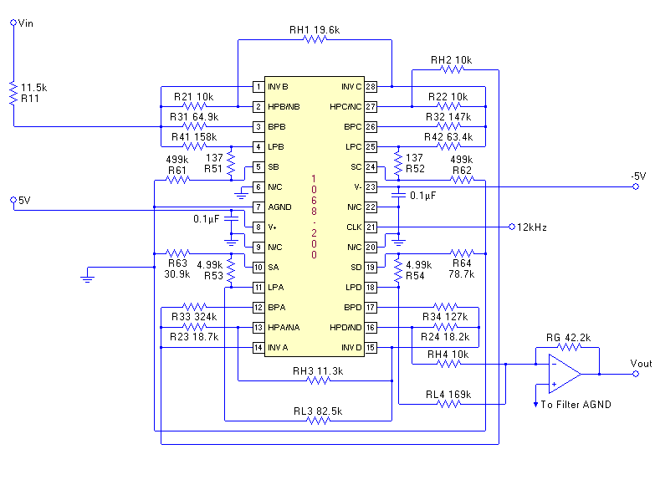
Fig. 2

The third stage (fig. 3) is an 8th Order Switched Capacitor 60 Hz Lowpass Filter. This filter is designed as part of a 12th order Butterworth lowpass filter with the other four poles created by the two active RC lowpass filters which preceed and follow the two switched capacitor stages. This stage uses the same 12 KHz external clock as the

previous stage, which can also be changed to 10 KHz for a 50 Hz cutoff frequency. The gain of this stage is 35 dB.

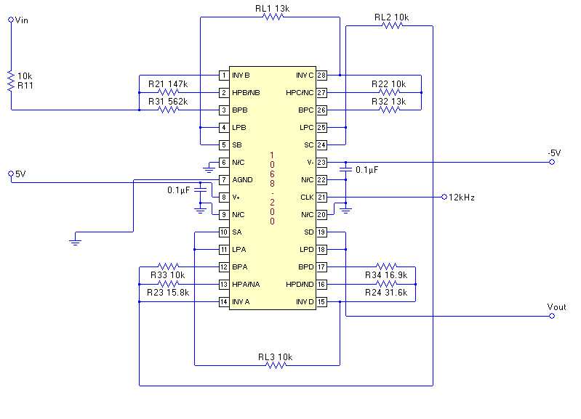
Fig.3

The final stage (fig.4) is a 2nd Order Active RC 60 Hz Lowpass Filter with the Q chosen to provide the final two poles of the 12th order Butterworth lowpass filter. This stage also provides antialiasing for the 12 KHz clock signal from the switched capacitor filters for use with data acquisition cards which require an external antialiasing filter. For lowest noise, the output of this stage is divided down to provide both high and lower gain outputs to match the signal levels for most sound cards. For 50 Hz rejection, the resistors R26 and R8 should be changed to 31.6K (1 % metal film).

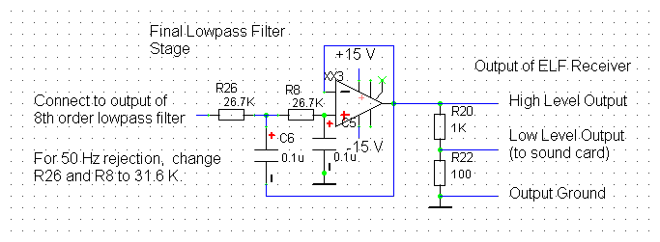
Fig.4

The clock circuit is not critical but should output a stable square wave signal. The power supply for this stage should be separate from the supplies for the rest of the receiver. The layout of the clock connection to the switched capacitor filter ICs is critical. Refer to the LTC1068 Data Sheet for more details. The LM555 can be used generating a clock frequency. I will post a suggested design soon.

All regulated power supplies should be constructed with adjustable voltage regulator ICs using external resistors to program the output voltage for lowest noise. Most regulator ICs with a set voltage output are usually very noisy and may cause problems.

Capacitors 1 uF and less in value should be non polarized metal film capacitors regardless of polarized representation in schematics. Metalized polypropylene capacitors are preferred for use in active RC filters because of lower dielectric absorbtion compared to metalized polyester capacitors.

Outdoor antennas should be constructed away from power lines and connected with dual coax lines to grounded lightning arrestors, and fused with fast-acting 0.25 Amp fuses before connecting to the input of the ELF receiver. It is normally not necessary to use optoisolators at the output of the receiver unless ground loop noise is a problem.

All of the parts for this design can be ordered from Digi-Key.com and many other sources.

I hope you will enjoy building and utilising my design to receive ELF signals. Please send any feedback or questions to:
ELF <stevew77@pacbell.net>

Steve Wingate

